**Black Bear Bank  
Project Description**

Mircea Ionut Dobre - 293117

Pavel Balan - 293129

Sandut Chilat - 293086

Manuel Gabriel Hagiu - 293144

**Supervisors:**[Henrik Kronborg Pedersen](https://via.itslearning.com/Dashboard/#)  
[Joseph Chukwudi Okika](https://via.itslearning.com/Dashboard/#)

**Software Technology Engineering**

**2nd Semester**

**February 2020**

**Table of content**

Background Description **1**

Problem Statement **2**

Definition of purpose **3**

Delimitation **3**

Methodology **4**

Time schedule **4**

Risk assessment **6**

Sources of Information **7**

Appendices

-Group contract

# Background Description

Traditional banking systems are the most popular type of financial institutions that aid in monetary management. The customers of a traditional bank are limited in their actions in terms of the bank’s regulations and current country legislation. Potential customers can do a few basic things such as: opening a bank account, withdrawing and depositing money - possibly through an ATM, exchanging between currencies (without a fee if one is the client of the specific bank), taking loans and stock exchange. All the walking that is done by a customer - from home to bank, or from the central bank branch to a secondary branch is time-consuming and today in the 21st century - time, speed, service availability and the lack of necessity of having to visit the offices are important, as every minute has a cost and in the end, time is money.

An alternative to the traditional bank is the neobank ([Aleksandre B, 2019](https://bitnewstoday.com/news/neobanks-have-arrived-is-the-market-trembling/)) - a type of direct bank that operates exclusively online without traditional physical branch networks. Some of them have also brought in new possibilities - such as cryptocurrency trading. Currently, in the modern world, people are used to traditional banking systems with physical branches where one has to wait for hours on end and stay in endless lines, just to do something that is achievable in a few clicks through web-banking.

Online banking has had a gradual increase in popularity in the past decade, and this trend is observed mostly in highly developed countries. For example, as of 2018, Nordic countries including Norway, Denmark, Finland, and Sweden all had online banking penetration rates of over 80 percent. In stark contrast, North Macedonia, Romania, and Bulgaria had penetration rates lower than 10 percent. The following statistics show a gradual increase in the popularity of online banking across Great Britain between 2007 and 2019 ([Cherowbrier, 2019](https://www.statista.com/aboutus/our-research-commitment)):

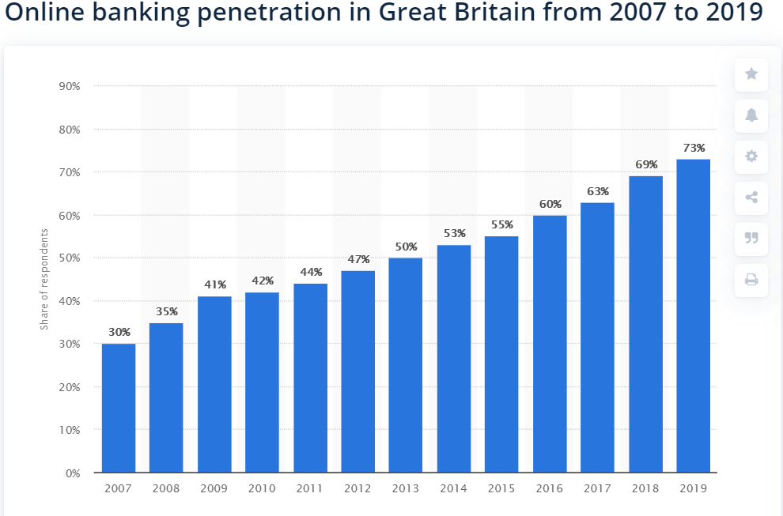

Another available solution available to customers is the Chime neobank. It allows the users to exchange funds between several currencies and make inter-bank transfers, all without a fee. However, it is only available to customers from the United States and it does not offer loans, something required for a full and comprehensive neobank system.

In conclusion, following the aforementioned statistics, more and more people are transitioning to an online solution for banking, as the traditional means of the financial activities through physical bank branches prove to be time-consuming and inefficient.

# Problem Statement

A client wants an online banking system that is easy to use and that doesn't have administration fees.

Questions to be answered are the following:

· How will the system handle transaction cancelation?

· What information should be known about the clients?

· How to immediately update the balance after finishing one transaction?

· How to make the system maintainable?

# Definition of purpose

The purpose is to create a banking system for potential clients that want a Neobank that allows the users to create an account and receive money to different accounts with different currencies and make loans, with a simple click on your device.

# Delimitation

* The system will not include any stock information.
* There will be no physical branches of the bank.
* There will be no bank-owned ATMs for financial transactions such as cash withdrawals.
* The system will not support cryptocurrency transactions and storage.

# Methodology

For this project, we will use multiple software development processes. One of them is the agile method SCRUM. The SCRUM method will allow us to work in a fast and efficient manner where everybody is focused on the task at hand ([Schwaber, 2017](http://www.jeffsutherland.org/oopsla/schwapub.pdf)).

*Starting scrum roles in our team:

-Mircea Dobre: Product Owner

-Pavel Balan: Scrum Master

-Manuel Hagiu: Development Team

-Sandut Chilat: Development Team

We will be making 9 sprints of a length of a week(7 days) each.

In this project we will also use the Unified Process(UP) framework which will allow our team to split the project into 4 phases making the development process easier.

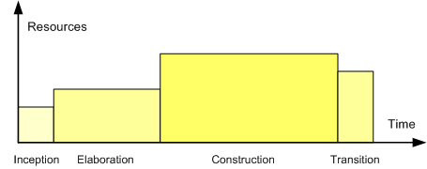

([GFLewis, English Wikipedia, 2006](https://commons.wikimedia.org/w/index.php?curid=10217873))

# Time schedule

The dates are subject to change due to unexpected events which may occur.

|  |  |  |  |  |  |  |  |  |  |
| --- | --- | --- | --- | --- | --- | --- | --- | --- | --- |
| Week | Pre-project planning | Week | Inception | Week | Elaboration | Week | Construction | Week | Transition |
| 7 | Group,  proposal | 12 | Scrum team, product backlog | 14 | Sprint 1 | 18 | Sprint 4 | 22 | Sprint 8 |
| 8 | Proposal acceptance | 13 | Product backlog | 16 | Sprint 2 | 19 | Sprint 5 | 23 | Sprint 9 |
| 9 | Project description |  |  | 17 | Sprint 3 | 20 | Sprint 6 |  |  |
| 10 | Project description feedback |  |  |  |  | 21 | Sprint 7 |  |  |
| 11 | Project description acceptance |  |  |  |  |  |  |  |  |

|  |  |
| --- | --- |
| Expected workload per ECTS per student | 27.5 hours |
| ECTS per student | 10 points |
| Expected workload per SEP2 per student | 275 hours |
| Group members | 4 members |
| Total expected workload per team | 1100 hours |
| Estimate cost per hour | ~200 dkk |
| Total estimated cost in dkk | ~220.000 dkk |
| Total estimated cost in euro | ~29.400 euro |

# Risk assessment

|  |  |  |  |  |  |  |
| --- | --- | --- | --- | --- | --- | --- |
| **Risks** | **Likelihood**  **Scale: 1-5**  **5 = high risk** | **Severity**  **Scale: 1-5**  **5 = high risk** | **Product of likelihood and severity** | **Risk mitigation e.g. Preventive- & Responsive actions** | **Identifiers** | **Responsible** |
| Not meeting the deadline | 3 | 5 | 15 | Stop wasting time playing video games, making a working product first then making it pretty. | High level of steam playtime, meaningless features being implemented | The whole team |
| Database not connecting during exam | 2 | 5 | 10 | Testing everything before exam | Program being glitchy | Mircea Dobre |
| Loss of files and notes | 4 | 3 | 12 | Saving everything on cloud solutions | Leaving laptop unattended, random papers inside the backpack | Pavel Balan |
| Not attending group meetings | 4 | 3 | 12 | Discussing the team meeting timeframe in advance to make sure every member can attend | Not responding to messages | Sandut Chilat, Manuel Hagiu |

# Sources of Information

1. Aleksandre B, 2019. *Neobanks have arrived - is the market trembling?* [online] Bitnewstoday. Available at: <https://bitnewstoday.com/news/neobanks-have-arrived-is-the-market-trembling/> [Accessed 29 Feb. 2020].
2. Daet-Gibson, B., 2019. *How a NeoBank in Australia today, can fit into your financial setup*. [online] Medium. Available at: <https://medium.com/@blakedaetgibson/how-a-neobank-in-australia-today-can-fit-into-your-financial-setup-8a6b2922c38> [Accessed 29 Feb. 2020].
3. Pritchard, J., 2019. *See How Mobile-Only Banks Can Help Save Money and Bank Conveniently*. [online] The Balance. Available at: <https://www.thebalance.com/what-is-a-neobank-and-should-you-try-one-4186468> [Accessed 29 Feb. 2020].
4. Chime Banking, 2020. *We're Changing the Way People Feel About Banking - Chime Banking*. [online] Banking Made Awesome. Available at: <https://www.chime.com/about-us/> [Accessed 29 Feb. 2020].
5. Ken Schwaber, 2017. *SCRUM Development Process*. [online] SCRUM . Available at: <http://www.jeffsutherland.org/oopsla/schwapub.pdf>[Accessed 29 Feb. 2020].
6. [Cherowbrier](https://www.statista.com/aboutus/our-research-commitment), 2019. Online banking penetration in Great Britain from 2007 to 2019. [online] <https://www.statista.com/statistics/286273/internet-banking-penetration-in-great-britain/>[Accessed 29 Feb. 2020]
7. GFLewis at English Wikipedia, 2006. - Transferred from en.wikipedia to Commons by Belgrano using CommonsHelper., CC BY-SA 2.5, <https://commons.wikimedia.org/w/index.php?curid=10217873> [Accessed 29 Feb. 2020]

**Appendices**

**Group Contract**

|  |  |  |  |
| --- | --- | --- | --- |
| Group Name (Optional) : |  | Date: | **14.02.2020** |

These are the terms of group conduct and cooperation that we agree on as a team.

**Participation**: We agree to....

Divide the responsibilities efficiently

Be open to new ideas

Let the team know in advance if one of the members has to miss a team meeting

Honor meeting time frames

**Communication**: We agree to…

Try to keep swearing to a minimum

Possess a good comprehension and ability of communication in the English language

Focus on solving problems, not blaming people

Respect each other

Respect constructive criticism

Respond to messages in a timely manner

**Meetings**: We agree to....

Meet at least twice a week

Be present for every meeting even if sick

Not be late for meetings

**Conduct**: We agree to....

Be calm and rational

Respect each other and the conditions of the contract

**Conflict**: We agree to....

Not argue over meaningless things

Not to escalate conflicts

Separate team members in conflict with each other

**Deadlines**: We agree to....

Respect time schedule

Respect all project deadlines

**Other Issues:**

Solve together any problems that appear inside the group

Help each team member solve problems even if they are not university related

|  |  |  |
| --- | --- | --- |
| **Group member’s name** | **Student number** | **Signature** |
| Mircea Ionut Dobre | 293117 |  |
| Pavel Balan | 293129 |  |
| Manuel-Gabriel Hagiu | 293144 |  |
| Sandut Chilat | 293086 |  |